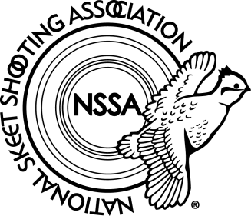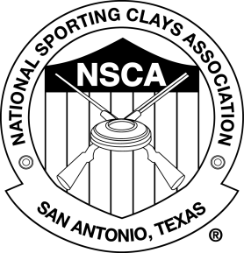
CONSENT FOR BACKGROUND CHECK
This is to inform you that the National Skeet Shooting Association/National Sporting Clays Association (hereinafter referred to as the “NSSA-NSCA”) may request a consumer report from a consumer reporting agency (CRA) in connection with your application to work with the NSSA-NSCA. Any information contained in these reports may be taken into consideration in evaluating your application and will be held in confidence.
For NSSA-NSCA purposes, a consumer report may include criminal history records, motor vehicle records, and employment verification.
The federal Fair Credit Reporting Act (FCRA) is designed to promote accuracy, fairness, and privacy of information in the files of CRA. Most CRAs are credit bureaus that gather and sell information about you to creditors, employers, landlords, and other businesses.
Your consent is required by law for the release of this information. Your signature on this form indicates you have carefully read and understand this notice and authorizes the release of a consumer report to the NSSA-NSCA for the purposes described above.
_____________________________________________________
(Printed) First Name, Middle Initial, Last Name

__________________________________________ _____________________
Signature Date
Additional information needed:
Date of Birth: _____________________ NSSA Member # ________________
Other name(s) used in the past 7 years (ie. Maiden name, aliases)
______________________________________________________________________________

